Dear Customer,

Thank you for your Order. We would like to draw your attention that after checking design file sent by you we have made certain observations and given possible suggestions for the same.

Click here to reply online https://www.pcbpower.com/Pcbpower/sign-in ➔ Exceptions section ➔ Select and reply

Exception: 1
You have ordered this as a single PCB with Assembly service for it.

Suggested solution :
For optimal assembly production we have changed the order details from Single PCB to a PANEL. We have also changed order detail parameters as below. We have recalculated the order price. Please see revised PI to see the price difference.
Panel by | PCB Power
PCB dimension | 40.00 x 40.00mm
Repeat | 3 x 2
PCBs/Panel | 6
Board Separation | Break-routing
Distance between two PCB's | 2.00mm
Panel border | 5.00mm
Panel Dim | 138.00 x 96.00mm

Exception: 2
We found that the conformal coating is required as per order detail.

Suggested solution :
We will provide our standard conformal coating.

Exception: 3
We have found that the footprint for the following reference designators as specified in your BOM do not match the gerber data. Either the footprint used during PCB layout is incorrect or manufacturer part numbers given in BOM is incorrect.
C1,C2,C3,C4,C5,C7,C9,C15
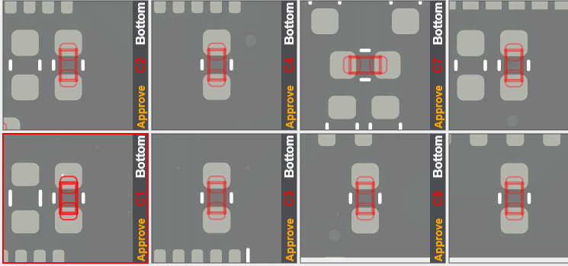

See next page...

D2,D3,D4 (1N4148)
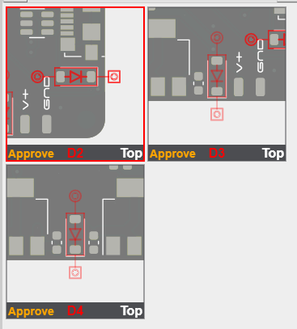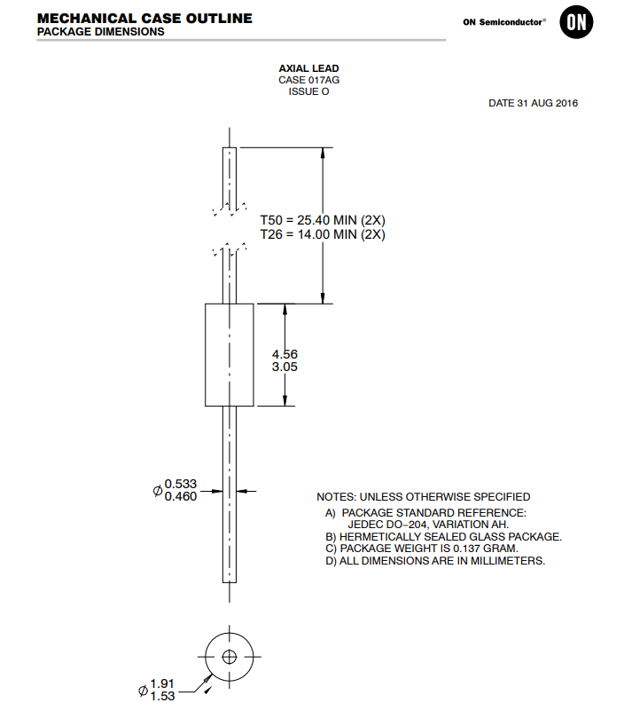

U5(MEM2075-00-140-01-A )- drill does not match as per datasheet
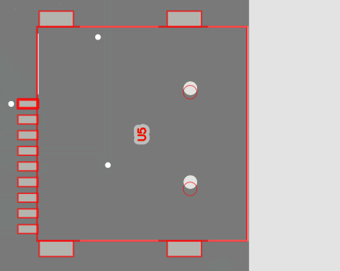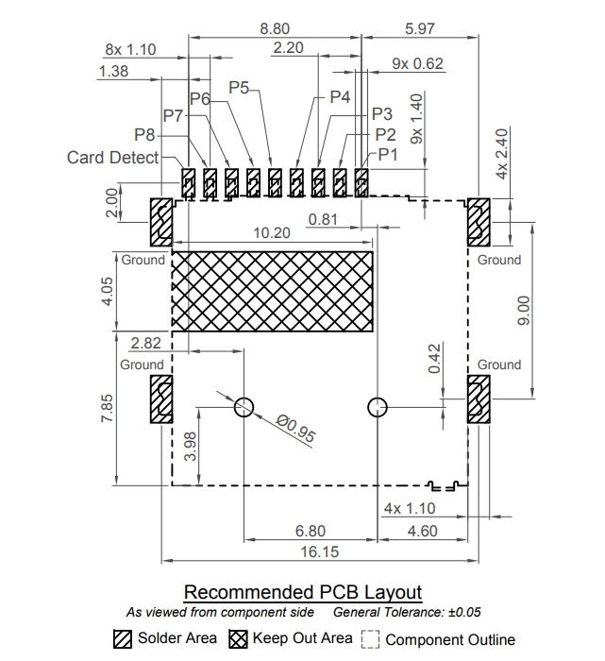

Suggested solution :
Please provide us correct data or correct manufacturer part number.

Exception: 4
We have not found datasheet or mechanical drawing for following components to verify footprint with gerber data.
J19, SW1

Suggested solution :
Please provide us datasheet.

Exception: 5
The following components are given in Pick-place file but not given in the BOM file.
J17, J20

Suggested solution :
Can we ignore it and continue as per BOM file?
See next page...

Exception: 6
As per gerber data blind drills as per below image are required but, we can not provide such blind-drill combination.
We support maximum 0.30mm end size for blind via but as per Gerber data 0.40mm end size blind via required.
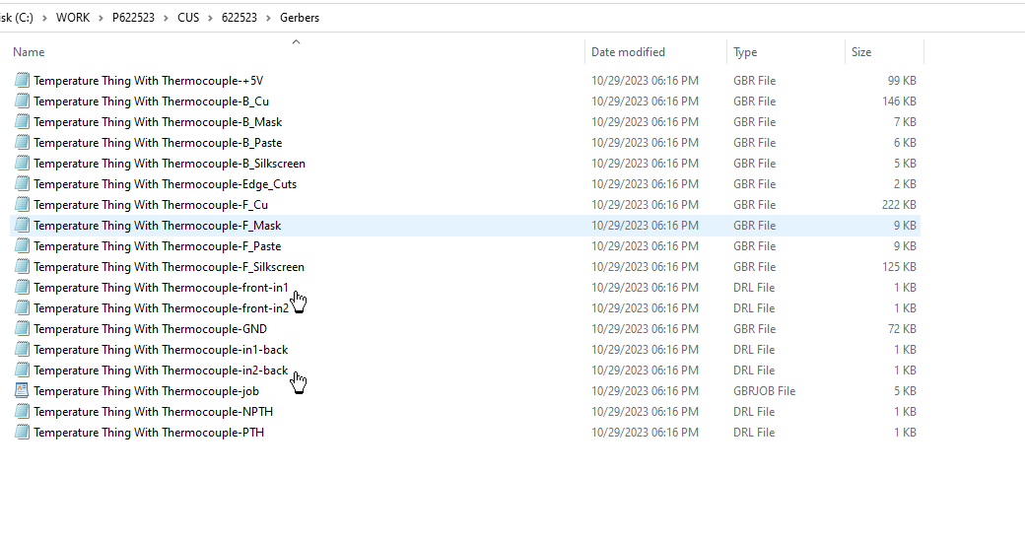

We can provide blind via and throgh holes in below cases:
- 1 to 2 , 1 to 3 and 1 to 4
- 1 to 2 , 3 to 4 and 1 to 4
- 2 to 3 , 2 to 4 and 1 to 4

Suggested solution :
We request you to make changes accordingly in gerber data.

Exception: 7
This is ordered with “BLACK” color solder mask.
For other than Green/Blue color solder mask, we required minimum MAR(Mask annular ring) of 0.10mm and MSM (mask to mask clearance) of 0.12mm. If it is less than we cannot provide solder dam/MSM as per our production standard.
In given gerber data we found MAR is of 0.00mm and MSM is of 0.25mm. So, we cannot provide solder dam.
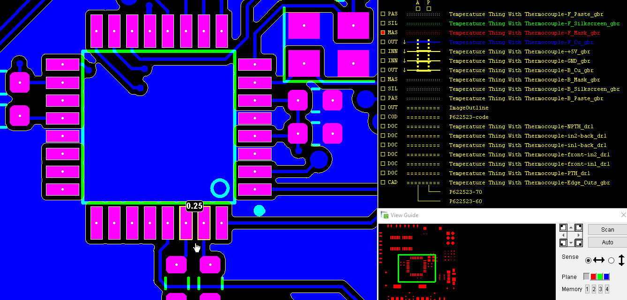
Example deviations in white - Not all deviations are shown

Suggested solution :
We will process order without solder dam.

See next page...

Exception: 8
We found mismatch between Gerber data and Order detail for below mentioned parameters.
PCB parameter | Order details | PCB data specifications | Found in…File name
Assembly side | Top | Top and Bottom | As per BOM File.
Blind and buried via | No | Blind via | As per BOM File.

Suggested solution :
We have consider details given in the Gerber data.
We have modified order detail accordingly to continue the order.
We have recalculated the order price. Please see revised PI to see the price difference.

Give your approval on line as fast as possible!
To review these technical observations as convenient as possible go to https://www.pcbpower.com/ and log into your account. Then proceed as follows:

Select Exceptions Tab to see orders with exceptions :
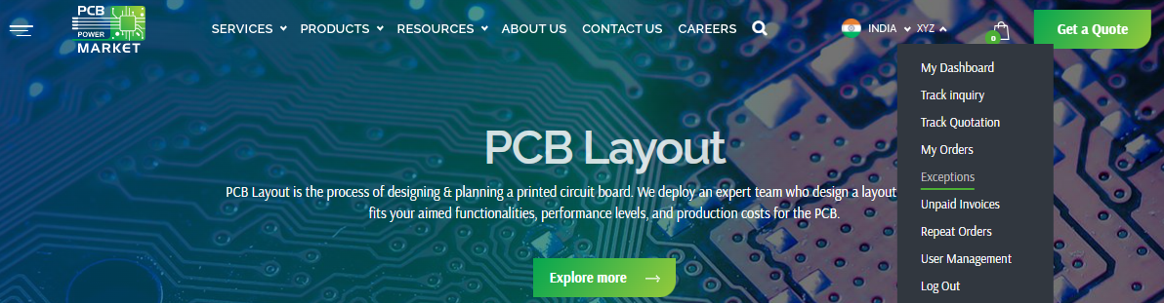

Select an Order Nr and download the exception to see exceptions details :
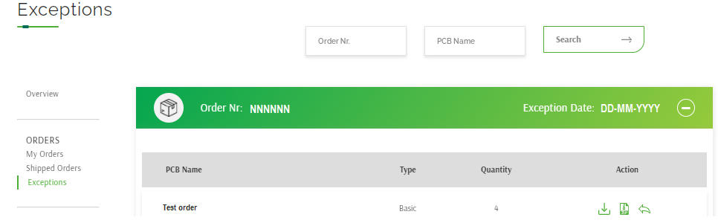

Click on Download button to download our exception file and review it :
* Use New gerber file option to provide modified gerber data :
* Use Exception reply option to provide your feedback in text/word/pdf file – no need to give gerber data again:
*** It is always better to provide all your required remark/feedback into gerber data zip file and reply as a New Gerber file instead of using Exception reply option :
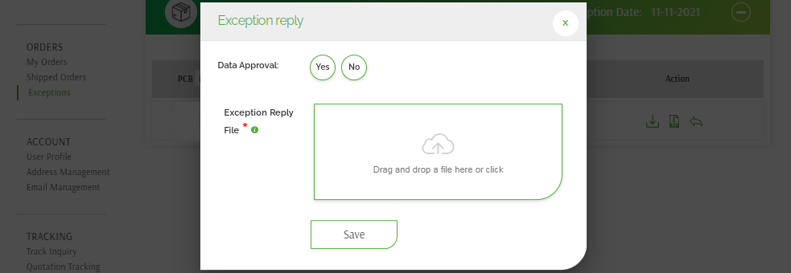

As you submit new gerber data, we will remove previously supplied gerber data. And consider this gerber data only for further process.

Please note that ship date will change based on the working days and the time that is taken by you to resolve the exception.
PCB Power’s Capability:

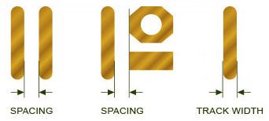
Circuit Layer:
 |  | Outer Layers | Inner Layers
For finished copper thickness of 1.0 Oz/35.00micron. | Min. Track width | 0.09 mm | 0.125mm
For finished copper thickness of 1.0 Oz/35.00micron. | Min. Spacing | 0.09 mm | 0.125mm
For finished copper thickness of 2.0 Oz/60.00micron. | Min. Track width | 0.125 mm | 0.175mm
For finished copper thickness of 2.0 Oz/60.00micron. | Min. Spacing | 0.125 mm | 0.175mm
For finished copper thickness of 3.0 Oz/95.00micron. | Min. Track width | 0.175 mm | 0.21mm
For finished copper thickness of 3.0 Oz/95.00micron. | Min. Spacing | 0.175 mm | 0.21mm

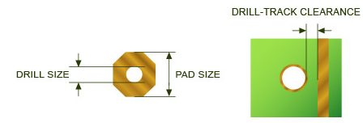

Drilling:
Minimum finished via drill size | 0.100 mm
Minimum annular ring – Outer layers | 0.105 mm
Minimum annular ring – Inner layers | 0.125 mm
Minimum via pad size – Outer layer | 0.460 mm
Minimum via pad size – Inner layer | 0.500 mm
Drill to track clearance for inner layer (up to 6-layer) | 0.250 mm

